Data Analytics

SESSION 1: INTRODUCTION

Assignment 1

1

Data Analytics

Table of Contents

1.Introduction............................................................................................................................................... 3

2. Objective....................................................................................................................................................3

3. Prerequisites.............................................................................................................................................. 3

4. Associated Data Files ............................................................................................................................... 3

5. Problem Statement................................................................................................................................... 3

6. Expected Output ....................................................................................................................................... 3

7. Approximate Time to Complete Task ...................................................................................................... 3

2

Data Analytics

**1. Introduction**

This assignment will help you understand the concepts learnt in the session.

**2. Objective**

This assignment will test your skills on the basics of Data Analytics.

**3. Prerequisites**

Not applicable.

**4. Associated Data Files**

Not applicable.

**5. Problem Statement**

1. Please mention true or false for the below statements:

a) Prescriptive Analytics is used to predict the future outcomes

**Answer: False.**

b) Base R packages are installed automatically

**Answer: False**

2. What is Recycling of elements in a vector?

**Answer: Recycling of elements is when we perform operations on two different vectors having different lengths. In it, the elements of the shorter length vector are used to completed the operations.**

3. Give an example of recycling of elements.

**> a<-c(1,2,3)**

**> b<-c(4,5,6,7)**

**> print(a*b)**

**Output:**

**[1]  4 10 18  7**

Below is the screenshot of R using recycling of elements in a vector.

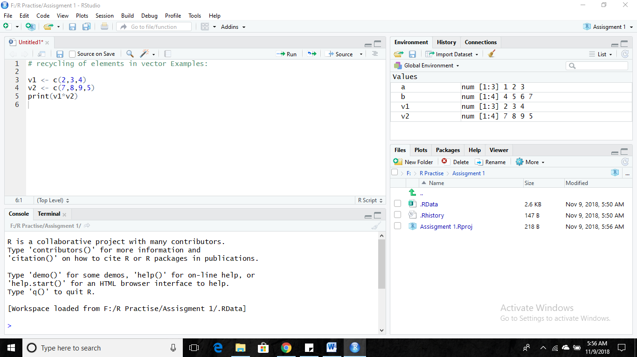

Data Analytics

**6. Expected Format**

1. R file should be submitted where applicable.

2. R file should be in PDF or in .r format

3. Proper screenshots of the outputs should be submitted as well

4. The r codes, if submitted in any other format, will be subjected to deduction in marks

Note: Your solution will not be entertained if it is any other format, e.g., .zip, .doc, .rtf etc.

**7. Approximate Time to Complete Task**

20 mins.

4